|  |  |
| --- | --- |
| **Orienteering**  **Nighttime Navigation** | C:\Users\james\OneDrive\BSA\Woodbadge\Project\EEE Flag Color.JPG |

**The North Star**

The North Star, named “Polaris”, unlike all the other stars is always located in the northern sky no matter the time of night or time of the year. Therefore if you can find it you know which direction is north without using a compass. The trick is that the North Star is only a moderately bright star so it’s easier to first look for two other constellations in order to find it. These constellations are the familiar “Big Dipper” and the lesser known but very easy to find “W” shaped constellation named Cassiopeia.

**The Big Dipper a.k.a Ursa Major Method**

Once you find the big dipper make a straight line starting from the two stars, farthest from the “handle”, and continuing until you reach the North Star. The distance between the Big Dipper and North Star can be measured by extending your arm out and measuring out two and half widths of your fist.

**The Cassiopeia Method**

The Big Dipper won’t always be visible in the sky so it’s good to know how to use Cassiopeia to find the North Star. Cassiopeia is rather easy to find by its “W” shape and is always located opposite of the Big Dipper across from the North Star. Once found you can roughly extend a line from the middle of the “W” to find the North Star which is also about two and a half fists apart.

**All Constellations Rotate Around The North Star**

Depending on when you look the Big Dipper and Cassiopeia could be to the left, right, above or below the North Star. It’s even possible that one of the two constellations will be hidden behind trees, hills, buildings or below the horizon. But one of the two should always be visible.

**Equipment:**

* A clear night time sky

**Expect The Constellations To Be Rotated**

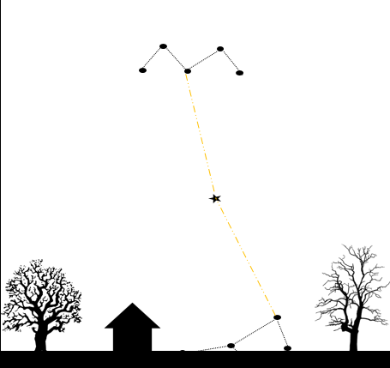 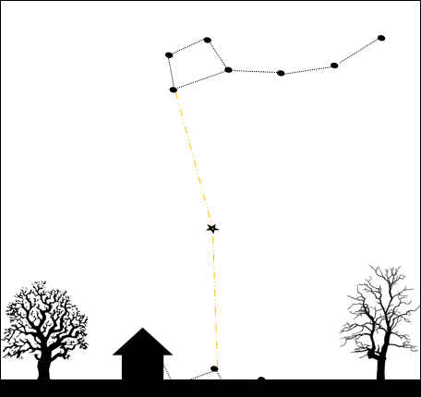

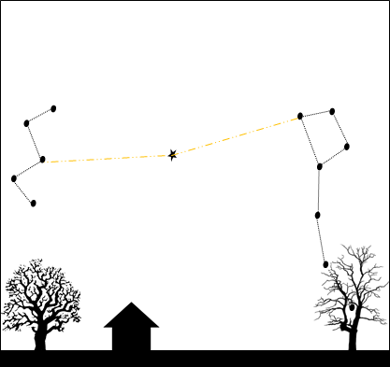

**The North Star Is Between The Big Dipper and Cassiopeia**

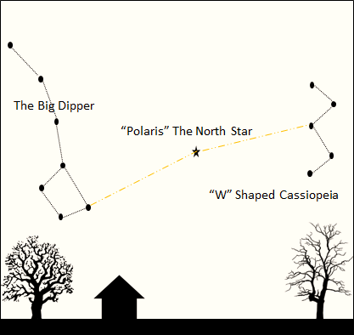

**Object:** Teach how to use the night time sky to find the north, south and other directions.

**The Sun And The Moon Are Never Found In The North**

Most people know that the Sun follows a path where it rises in the East, is in the South at noon and sets in the West. This path is called the “ecliptic” and it’s not just followed by the Sun but also by the Moon and the planets. Therefore one can know what ever direction they find the Sun, Moon, Mars, etc. that direction is not North but perhaps East, South or West.

**Orion At Various Angles Being Used To Find South**

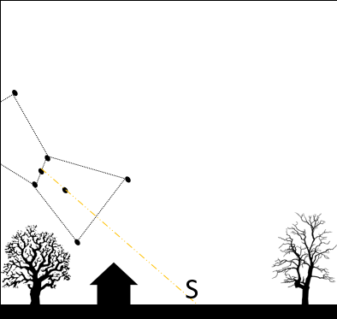 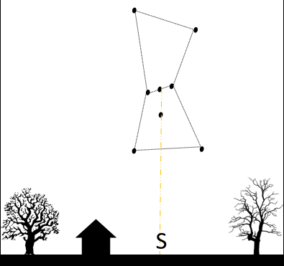

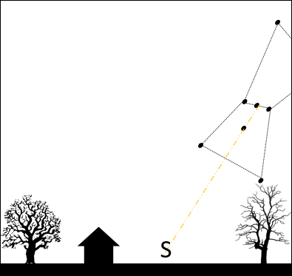

**Finding South Using Orion**

In winter it is possible to use another easy to find constellation named Orion the Hunter to find South. Once you find the familiar shape of Orion extend a line from the middle “belt” star through the star below and continue this line until you reach the horizon. This point on the horizon is South.

Take note that like all constellations Orion rotates in the sky and may appear at various angles, that it isn’t visible in the summer and even in winter may not always be visible depending on the time of night.s